**1. The CEO wishes to see information about the profits and sales per product category during the last three years. Therefore, create effective visuals that present the sales per product category and the profits per product category for the last three years.**

**Title:** Aim is to draw information about profits and sales per product category during last three years.

**Summary:** Let us investigate the key points to visualize the report in best way possible:

* Concentrating on profits and sales as per product category for certain duration.

**Introduction:**

We are extracting data of profits and sales from the orders dataset. And visualizing the data in graphical representation to make the audience understand the visualization is most effective way.

**Methods and findings:**

To draw the required visualization from the requirement we need to follow the instructions.

* After trying different graphs and plots, this horizontal bar graph helps us to visualize the report in the most efficient way.
* Drag and drop the profit and sales from measures to the columns.
* Drag and drop the category and order data in the rows.
* To get the last three years data we use filters on order data and select only the years that are required.
* To get the data that the bars are carrying drag and drop the sales and profit fields to the label.
* And to show different color intensity based on the profits it carry, we need to drag and drop the profit to the color.

**Screen shot of this visualization:**

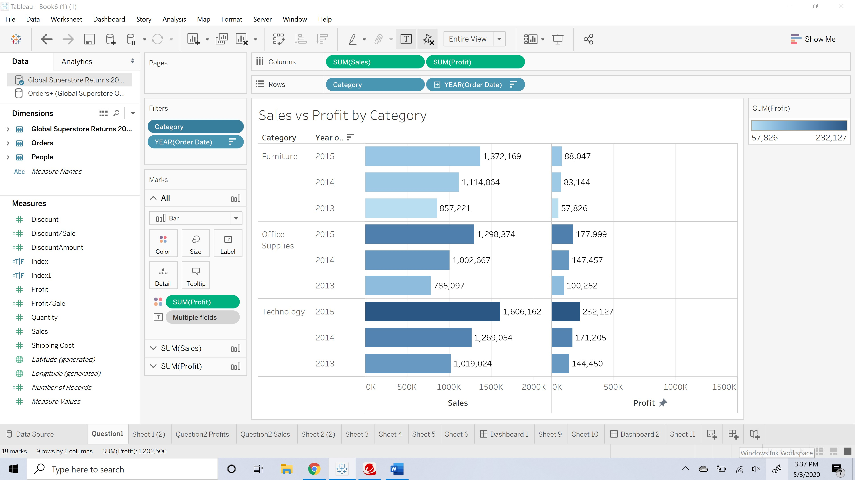

**Conclusion:**

So, this report shows the profit and sales per product category for last three years with labeling as well.

**References:**

1. Tableau training sections.
2. Class learning modules.

**2. Make clear which countries are the most profitable for the company and the profits per product category. In addition, the CEO wants to see the products sales with the least sales for some product categories, thus find out the countries with the lowest level of sales during the last three years.**

**Title:** Aim is to detect countries which has the most profitable profits per product category during the last three years.

**Summary:** In this report we are looking for the most profitable country per product category.

* We use only concentrated on the orders data set.
* Creating new parameter to find the top sales.

**Introduction:**

We consider mainly the orders dataset and used the data that is required to obtain the desired result of visualization. Our main purpose is to get the country which has most profitable for the company.

**Methods and findings:**

To draw a required visualization from the requirement we need to follow the instructions.

* After trying different graphs and plots, this horizontal bar graph helps us to visualize the report in the most efficient way.
* Drag and drop the country and category from dimensions to the rows.
* Drag and drop the sum of profits to the text, color in marks and on to the columns as well.
* To get the last three years data we use filters on order date and select only the years that are required.
* Now create a new parameter and name it as index which carries a mathematical equation to measure the top few countries which has most profitable sales.

**Screen shot of the above visualization:**

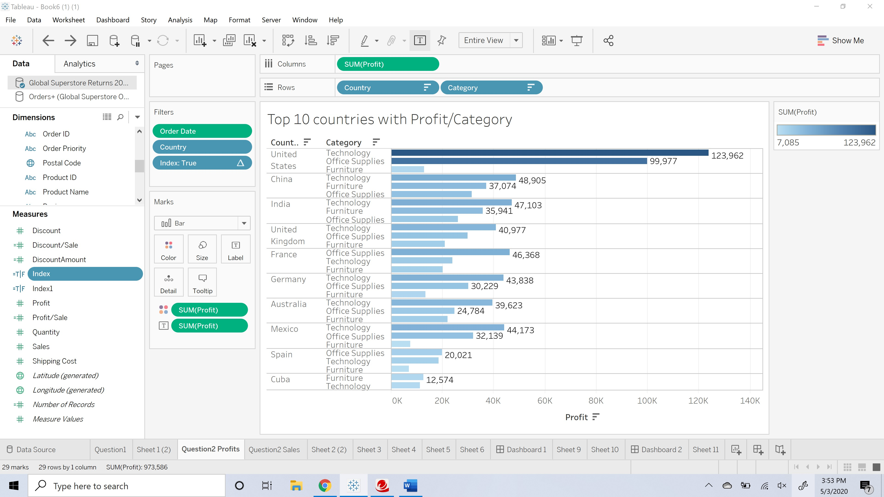

**Conclusion:**

So, this report show the most profitable country based on the profits per product category with labeling as well.

**References:**

1. Tableau training sections.
2. Class learning modules.

**Second part of the 2nd question:**

**Title:** Aim is to detect countries which has the least sales per product category during the last three years.

**Summary:** Drawing the least sales country from the plot of sales per product category.

**Introduction:**

We consider mainly the orders dataset and used the data that is required to obtain the desired result of visualization. Our main purpose is to get the country which has least sales per product category.

**Methods and findings:**

To draw a required visualization from the requirement we need to follow the instructions.

* After trying different graphs and plots, this horizontal bar graph helps us to visualize the report in the most efficient way.
* Drag and drop the country and category from dimensions to the rows.
* Drag and drop the sum of sales to the text, color in marks and on to the columns as well.
* To get the last three years data we use filters on order date and select only the years that are required.
* Now create a new parameter and name it as index which carries a mathematical equation to measure the top few countries which has least sales.

**Screen shot of the above visualization steps:**

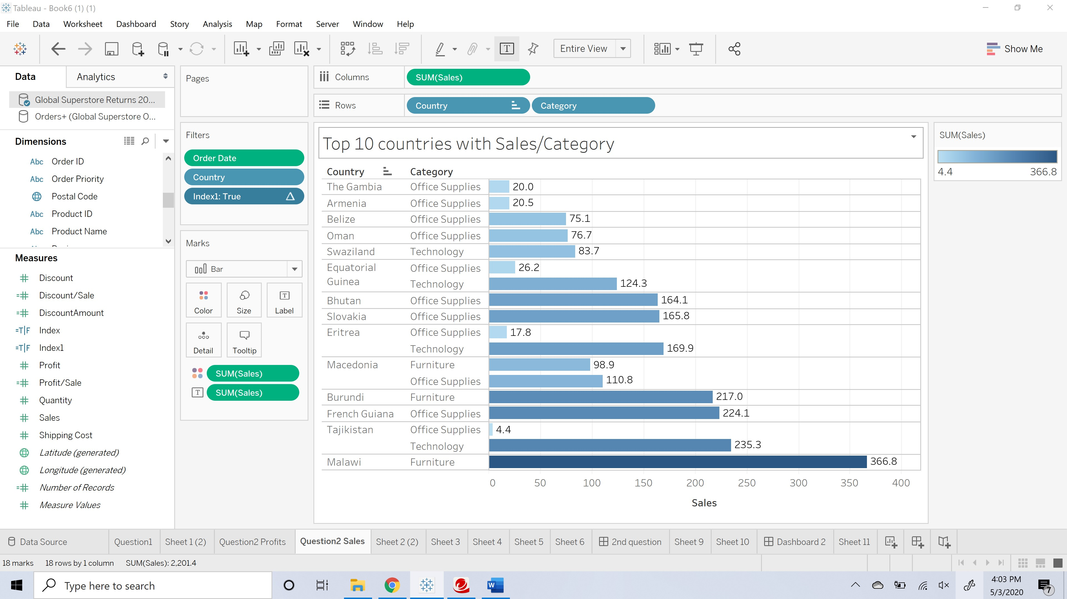

**Conclusion:**

So, this report show the least sales country based on the sales per product category with labeling as well.

**References:**

1. Tableau training sections.
2. Class learning modules.

**Screen Shot of the dashboard Visualization Report for profits and sales:**

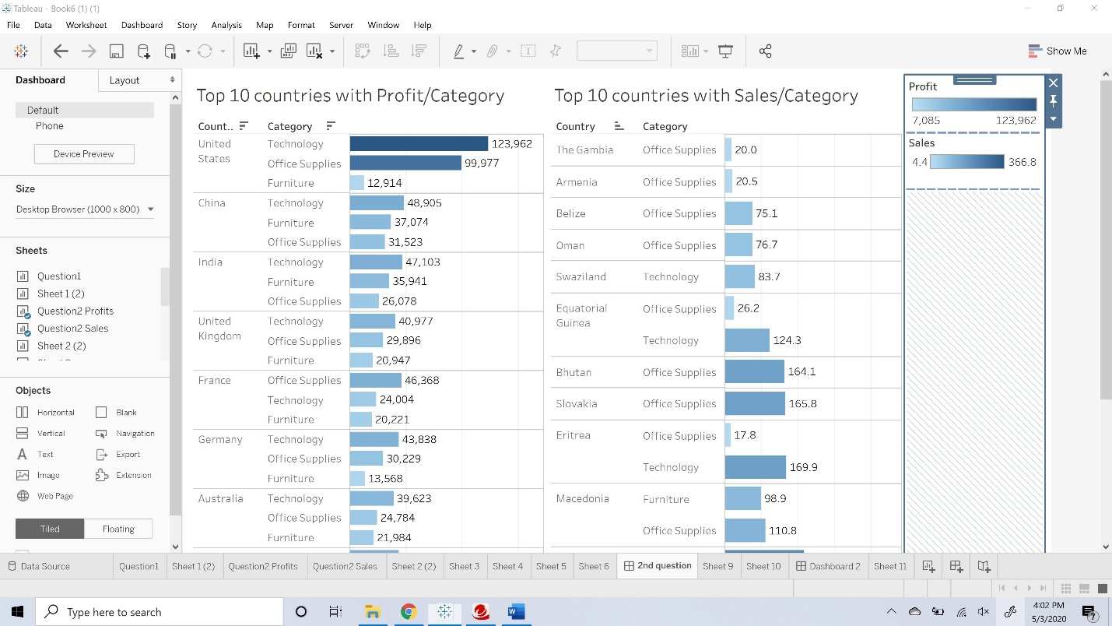

**3. As the company wants to provide a bonus for the top salespeople, find the people with the higher profits and sales during the last five years and depict their performance per product category.**

**Title:** Aim is to detect the top salespeople and find the people with higher profits and sales during the last five years. Also draw their performance per product category for last five years.

**Summary:** Representing the data and drawing conclusions that are based on the requirement which is identifying the top salespeople based on their performances per product category for last five years.

**Introduction:**

We consider dataset which has both returns and orders. Extracting those datasets into the data source and join those datasets to extract every data that is needed to get the visualizations in best possible way. By using the data that is present in the data on the left side of the worksheet.

**Methods and Findings:**

To draw a required visualization from the requirement we need to follow the instructions.

* Create one more measure profit/sale with an equation of Sum of profit/Count of order ID.
* After trying different graphs and plots, these horizontal bars help us to visualize the report in the most efficient way.
* Drag and drop the profit, sales, discount and profit/sales the one we created from measures to the rows.
* Drag and drop the category to the color in marks.
* Drag and drop the person on to the columns.
* Drag and drop order date to the filters.

**Conclusion:**

So, this report shows the person who has the best profit, best sales, giving certain discount to improve sales. And finally, with that profit/sales measure we can draw the person who made the better profits.

**References:**

1. Tableau training sections.
2. Class learning modules.

**Screen Shot of the Visualization Report:**

